

SIMATS ENGINEERING

Saveetha Institute of Medical and Technical Sciences
Chennai- 602105

Student Name: M Nishanth Reg. No.: 192511154
Course Code: CSA5115 Slot: A
Course Name: Cryptography and network security
Course Faculty: Dr. T. Sangeetha
Project Title: SECURE ONLINE VOTING SYSTEM USING CRYPTOGRAPHY
Module Photographs:
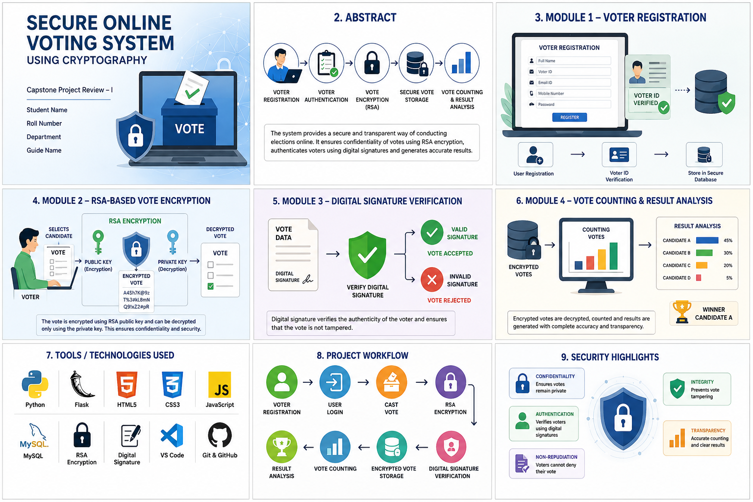
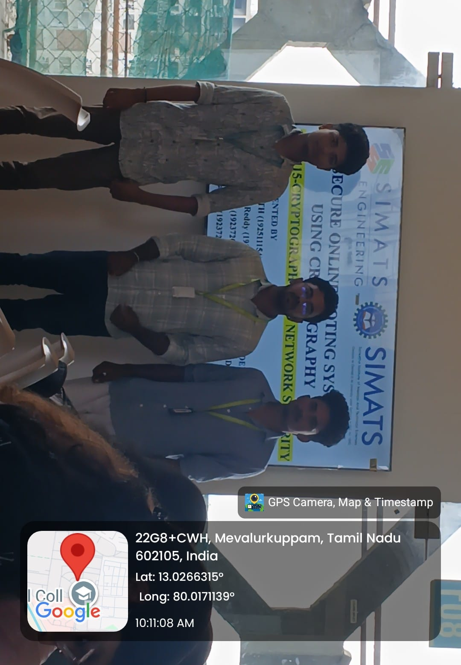
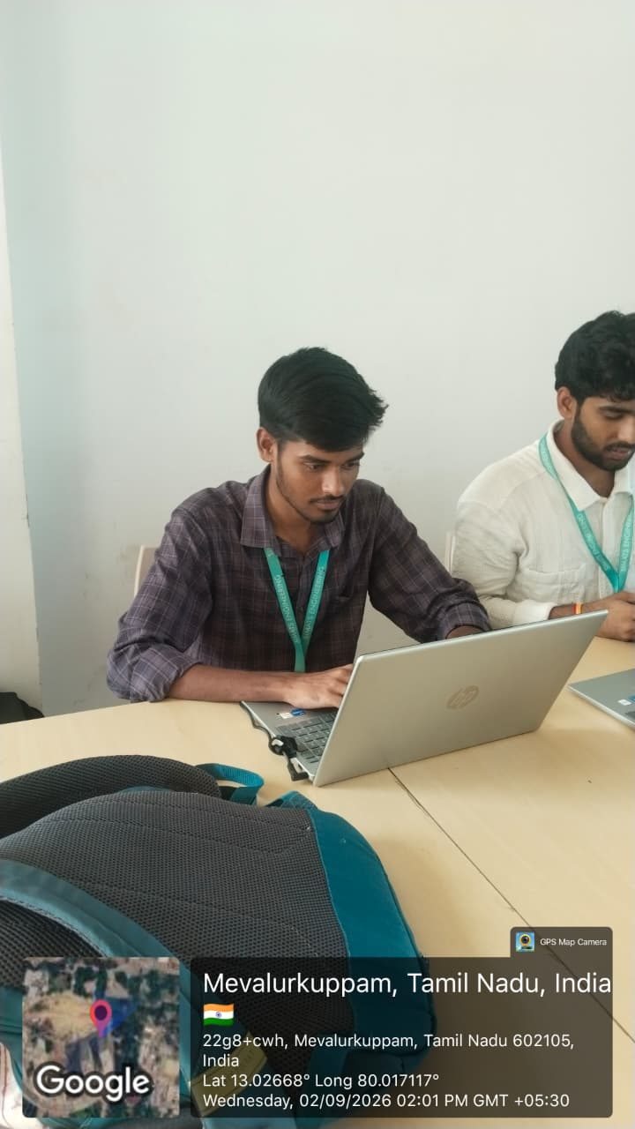
Project Description:
My contribution to the project was the development of the Digital Signature Verification module for the Secure Online Voting System Using Cryptography. The main purpose of this module is to verify the authenticity and integrity of each vote before it is accepted into the system.
In this module, a digital signature is generated using the voter’s private key. During verification, the system uses the corresponding public key to verify the signature. This ensures that the vote was submitted by an authorized voter and that the vote has not been modified during transmission.
The model works by receiving the encrypted vote and digital signature, verifying the signature using cryptographic algorithms, and checking the authenticity of the submitted data. If the signature is valid, the vote is accepted and stored securely. If the signature verification fails, the vote is rejected.
This module helps provide authentication, data integrity, non-repudiation, and protection against unauthorized vote modification, making the online voting system more secure and reliable.

Student Signature Guide Signature

